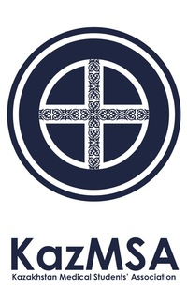

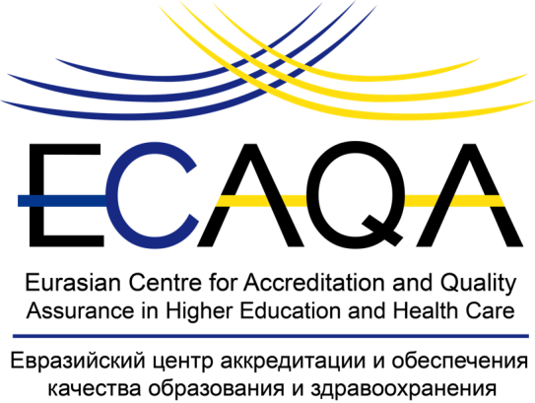

|  |  |  |  |
| --- | --- | --- | --- |
| |  |  |  | | --- | --- | --- | | **MEMORANDUM OF COOPERATION**  **between**  **The Eurasian Centre for Accreditation and Quality Assurance in Higher Education and Health Care (ECAQA),**  **Republic of Kazakhstan, Almaty**    **and**  **The Kazakhstan Medical Students' Association (KazMSA),**  **Republic of Kazakhstan, Nur-Sultan**  **Date: March 5, 2020**    **Memorandum of Cooperation**  **between**  **The Eurasian Centre for Accreditation and Quality Assurance in Higher Education and Health Care (ECAQA),**  **Republic of Kazakhstan, Almaty**  **and**  **The Kazakhstan Medical Students' Association (KazMSA),**  **Republic of Kazakhstan, Nur-Sultan**  The Parties to this Memorandum of Cooperation are The Eurasian Centre for Accreditation and Quality Assurance in Higher Education and Health Care (hereinafter referred to as ECAQA) that is represented by Director General Saule Sergaziyevna Sarsenbayeva and The Kazakhstan Medical Students' Association, Republic of Kazakhstan, Nur-Sultan, (hereinafter referred to as KazMSA) that is represented by President Arman Adiluly Baimbetov,  hereinafter referred to as the Parties  **ECAQA** is a non-governmental, non-profit organisation for quality assurance of higher education and training of healthcare professionals. ECAQA contributes to the development of the quality assurance system for professional education in healthcare by introducing international principles and standards for quality assurance of higher education, developing institutional capacity and a quality culture at educational organisations, and conducting research in education and public health.  **KazMSA** is a Republican Public Association, a non-profit non-political independent organisation of medical students and recent medical graduates in Kazakhstan. KazMSA was officially established by the Legislation of the Republic of Kazakhstan as a public association in 2015. KazMSA includes students from 9 medical universities of Kazakhstan, which form local committees. The organisation is fully managed by students, who form executive and supervisory committees. In 2016, KazMSA became a full member of the International Federation of Medical Students Associations (IFMSA) at the IFMSA's 65th General Assembly (MM2016 Malta).  **Recognizing the importance of accreditation in quality assurance and development of medical and pharmaceutical education;**  **Taking into account the achievements of each Party in quality assurance of medical and pharmaceutical education; and**  **Intending to strengthen and expand cooperation and mutual assistance in the provision of education in the Republic of Kazakhstan on the basis of the principle of equality and mutual benefit,**  **Have reached the following understanding to *interalia*:**   1. **Cooperation**  * In order to improve relations between the Parties on the basis of the principles of reciprocity and equality, the Parties agree to long-term cooperation. * The Parties agree to establish and develop cooperation in evaluation and accreditation of medical and pharmaceutical education. * The activities of the Parties will be aimed at improving understanding of the approach of both Parties to quality assurance of education and related systems. * Cooperation or the purpose of this Memorandum will be carried out in accordance with the legislation of the Republic of Kazakhstan.   **2. Subject**  This Memorandum provides:   * areas of cooperation for the development and implementation of joint projects, events and other forms of cooperation in order to achieve effective results; * focus of the efforts of both Parties on the institutional development of medical education organisations in accordance with the needs of the health care development of the Republic of Kazakhstan; * joint interest of both Parties to improve the educational programmes of medical education organisations in accordance with the needs of practical health care.   **3. Types of activity under this Memorandum:**  To achieve common goals and results, the Parties consider without limiting the following:   * Provision of candidates in the relevant specialty from among their members (students, interns, master’s degree students, residents, PhD programme students, graduates of medical universities) to the ECAQA Expert Board, upon request; * KazMSA’s assistance in the formation of the External Evaluation Commission on accreditation (institutional and/or specialized), provided that ECAQA constitutes an Unpaid Services Contract with a specific individual; * KazMSA’s assistance in attracting KazMSA members to participate in ECAQA training events on accreditation of medical and pharmaceutical education; * Exchange of information and expert knowledge that will include information on training programmes in which each Party has an interest, taking into account any basic requirements of confidentiality; * Exchange of materials on education and science, publications and scientific information; * Provision of online access to the database in the custody of the Parties, which is limited by the scope of this cooperation; * KazMSA’s involvement in ECAQA training seminars, conferences, workshops and other events dedicated to relevant issues of health care and medical education; * Development and implementation of joint innovation or research projects; * Participation in events, seminars or conferences organised by one of the Parties; * Joint publications.   **4. Agreements**  If the Parties make a decision on joint participation in a certain project (joint activity), the Parties may sign a Joint Activity Agreement that establishes the participation shares of each of the Parties, stages (terms) of fulfillment of obligations, distribution of income and expenses and other conditions having significance for the implementation of the joint project.  **5. Cooperation Conditions**   * Both Parties consider this Memorandum as a declaration of intent, which does not entail any legal and financial obligations for the joint activities of the Parties. * The Parties agree that all practical issues which are related to the organisation of specific activities on the basis of the clause 3 of this Memorandum shall be agreed separately and agreed between authorized representatives of both Parties. * The Parties respect the principles of reciprocity and equality.  1. **Privacy Policy**   The Parties are obliged to retain the information received from each other in the process of joint activities in confidence, excluding those data and information that has become generally known for reasons attributable to one of the Parties.   1. **Terms and Conditions of this Memorandum**   The Memorandum is concluded for a period of 5 years from the date of its signing and will be automatically extended for the same period if neither Party informs other Party in writing of its intention not to extend the Memorandum three months prior to the expiration of the next period.  The Memorandum comes into force from the date of its signing.  The Memorandum may be amended at any time with the consent of both Parties.  The Memorandum may be terminated by any of the Parties providing at least 6 (six) months notice.  This Memorandum is signed in duplicate having equal legal force, one for each of the Parties.  In case of a change of addresses, details and other data, the Parties are obliged to immediately notify each other by providing official notifications.   1. **Management**   The Director General of ECAQA and the President of KazMSA are responsible for managing the Memorandum of Cooperation.  This responsibility may be delegated to the appropriate employee or member of the organisation in relation to specific areas of the cooperation.   |  |  | | --- | --- | | **Director General of ECAQA**  S.S. Sarsenbayeva  */signature/*  [*Seal*: The Eurasian Centre for Accreditation and Quality  Assurance in Higher Education  and Health Care,  Non-Profit Organisation]  address: 75 Karasay Batyr st.  Almaty, 050029  Republic of Kazakhstan  [info@ecaqa.org](mailto:info@ecaqa.org)  +77013291665 | **President of KazMSA**  A.A. Baimbetov  */signature/*  [*Seal*: The Kazakhstan Medical Students' Association, Republican  Public Association]  address: 135 st., bldg. 3  Internatsionalnyy  housing estate, “Almaty” District,  Nur-Sultan  [kazmsa-kazakhstan@ifmsa.org](mailto:kazmsa-kazakhstan@ifmsa.org)  <https://vk.com/kazmsa>  +77079808809 |   D:\Downloads\IMG-0543.png | |